**Chapter 2 Task**

**Instructions:**

**-Study well and please attach Screen shots from the executable code in addition to sample of queries' results in your Answers.**

**- If you want to know any column name in a specific table you have to apply describe command: desc table_name.**

**-HR schema:**

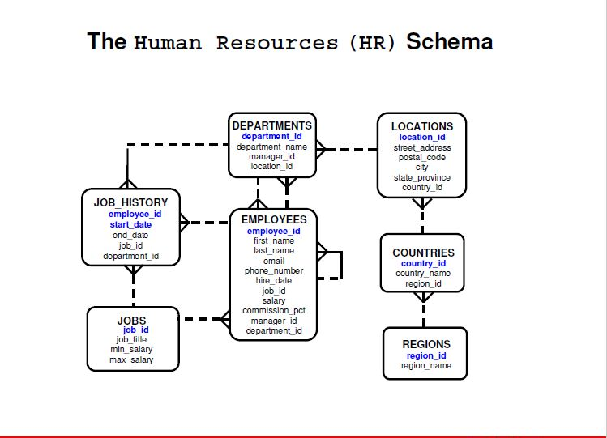

1. **Display the full name , employees’ numbers and salaries for the first 5 rows [by using in the condition: where rownum <= 5]**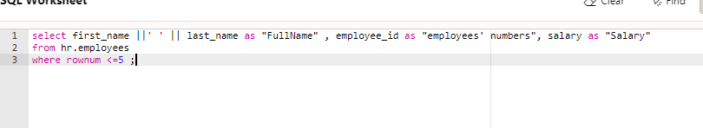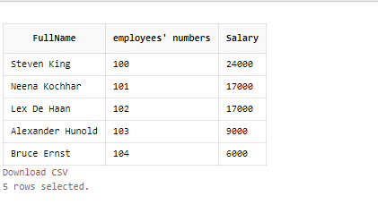
2. **Display the name and salary for all employees whose salary in the range of 3500$ and 7200$.**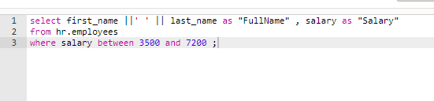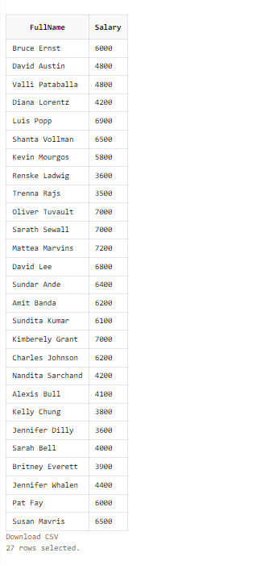
3. **Display the name, salary and commission for all employees who earn commissions, Sort data in descending order of salary and commissions.  
   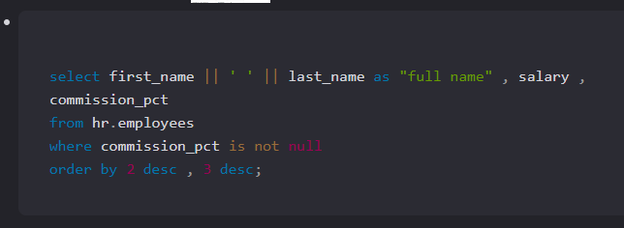**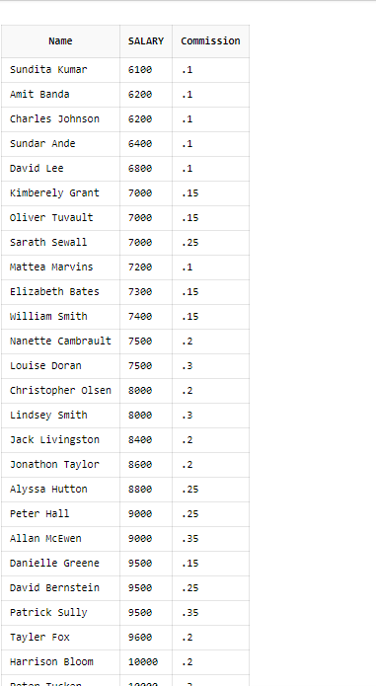
4. **Display the name, job and salary for all employees whose job is Clerk or Analyst and their salary is not equal to $1000,$3000 or $5000**
5. 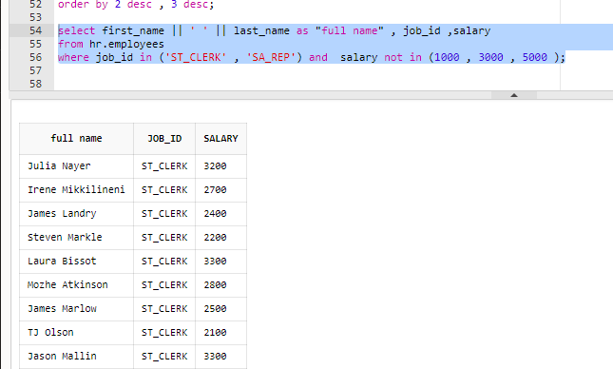notice … last line can be  
     
   **where job_id in ('ST_CLERK' , 'SA_REP') and not (salary in (1000 , 3000 , 5000 ) );**
6. **Display all information about employees whose names end with letter ‘r’.**

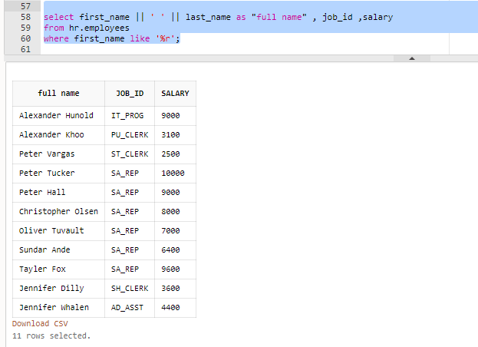

1. **Display the employees Id, name who earns more than 5000 LE month and sort the result in an ascending order.  
   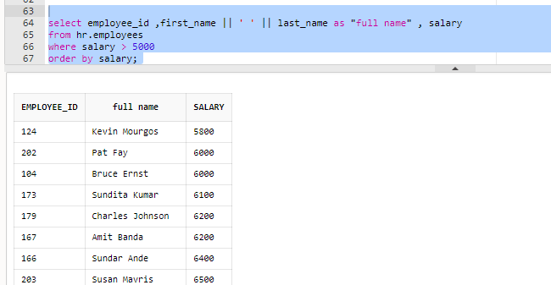**
2. **Display the employees Id, name who earns more than 25000 LE annually and sort the result in a descending order.**

**Code**select employee_id ,first_name || ' ' || last_name as "full name" , salary

from hr.employees

where salary*12 > 25000

order by salary desc;

**shots**

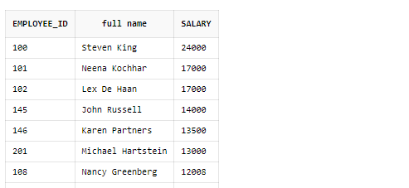

1. **Display the Departments full data of those which their names start with "I” letter.**

**Code**select *

from hr.departments

where department_name like 'I%';

**shots  
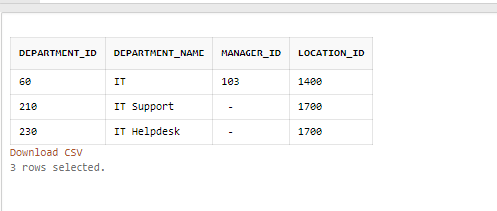**

1. 
2. **display all the employees in department 100 whose salaries not from 4000 to 5500 LE monthly.**

**code**

select employee_id

from hr.employees

where (department_id = 100) and not (salary between 4000 and 5500);  
shots

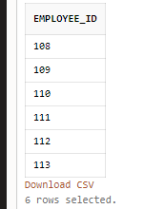

1. **Display number, job title and full name for all employees   
   who work in the department ,  
    you’ll enter its number at run-time .  
   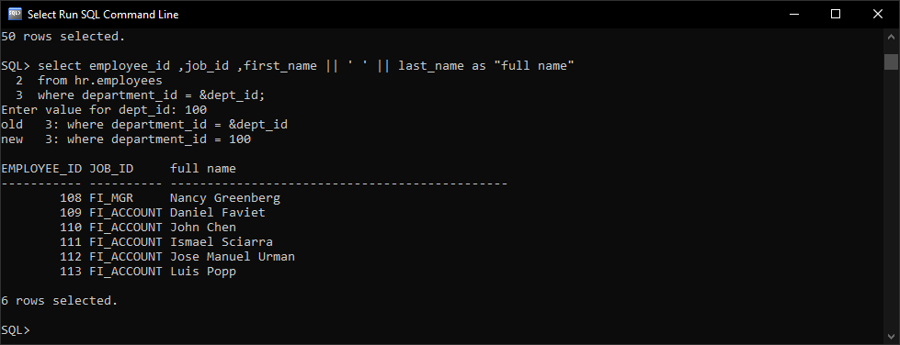**

1. 
2. **Display all information about jobs which their minimum salaries between 3000 and their maximum is 8000.**

**Code  
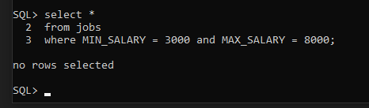**

1. **Display   
   department number and manager number   
   for the department**which you’ll specify its name and department number as an order at run-time. 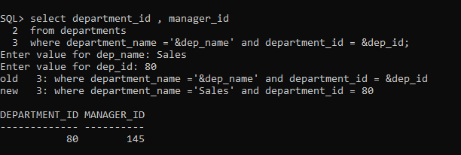
2. 
3. **Display all information of employees who don’t have managers.**



